X9C103 Solid-State Potentiometer 10kΩ
https://www.amazon.com/dp/B07Y23SY7L?ref=ppx_yo2ov_dt_b_fed_asin_title
https://www.renesas.com/en/products/x9c103?utm_source=renesas&utm_medium=datasheet&utm_campaign=x9c102-103-104-503-ds-description
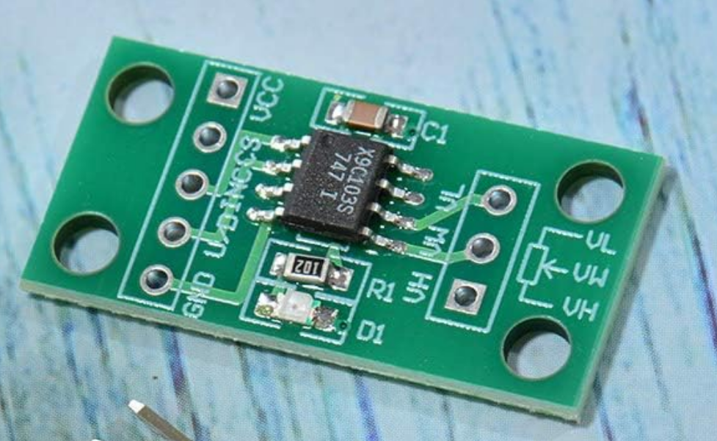

- Solid-State Potentiometer
- Three-Wire Serial Interface
- 100 Wiper Tap Points
- Wiper Position Stored in Non-volatile Memory and Recalled on Power-up
- 99 Resistive Elements
- Temperature Compensated
- End-to-End Resistance, ±20%
- Terminal Voltages, ±5V
- Low Power CMOS
- VCC = 5V
- Active Current, 3mA max.
- Standby Current, 750µA max.
- High Reliability
- Endurance, 100,000 Data Changes per Bit
- Register Data Retention, 100 years
- X9C102 = 1kΩ
- X9C103 = 10kΩ
- X9C503 = 50kΩ
- X9C104 = 100kΩ
- Packages
- 8 Ld SOIC
- 8 Ld PDIP
- Pb-Free Available (RoHS Compliant)

Module control connections
Module pin | Function | ESP32 connection
VCC | Module power | 5 V
CS | Chip select | ESP32 GPIO
INC | Wiper step clock | ESP32 GPIO
U/D | Direction | ESP32 GPIO
GND | Ground | Common ground
VH | Potentiometer high terminal | AD9833 conditioned signal
VW | Wiper | OP484 input
VL | Potentiometer low terminal | Buffered 2.5 V reference

The X9C103 is controlled by pulses rather than SPI or I²C:
- CS enables the device.
- U/D selects the direction.
- Each falling edge on INC moves the wiper one position.
- It has 100 wiper positions.
- The position can be stored in nonvolatile memory.
The X9C103 has a nominal 10 kΩ end-to-end resistance, ±20% tolerance, and approximately 40 Ω typical wiper resistance. Its analog terminals support signals within the needed range for this circuit. Renesas X9C103 datasheet
The 3.3 V ESP32 control outputs should be compatible with its digital control inputs while the module operates from 5 V, but all grounds must be connected.
Important limitations
This is a useful prototype part, but probably not the ideal final amplitude-control component:
- Only 100 positions, giving roughly 1% amplitude increments
- No direct position readback
- The ESP32 must track the wiper position
- On startup, firmware may need to “home” it by sending at least 99 downward pulses
- ±20% resistance tolerance
- Limited nonvolatile-memory write endurance
- Switching between taps can introduce a small amplitude step or transient
- Signal bandwidth and distortion should be measured experimentally
Avoid saving the position to nonvolatile memory every time the user moves the amplitude slider. Its memory is rated for a finite number of writes. For PocketLab, I would home the wiper to zero at startup and maintain its position in firmware.

